**Installation: Database**  
  
1] Download and install Xampp.

<https://www.apachefriends.org/download.html>

2] Open project files. Go to Source Code > RISFx > ris.sql. Copy all of the text in this document.

3] Open Xampp, start Apache and MySQL. Once started, click on the admin button for MySQL to open myPHPAdmin in browser.

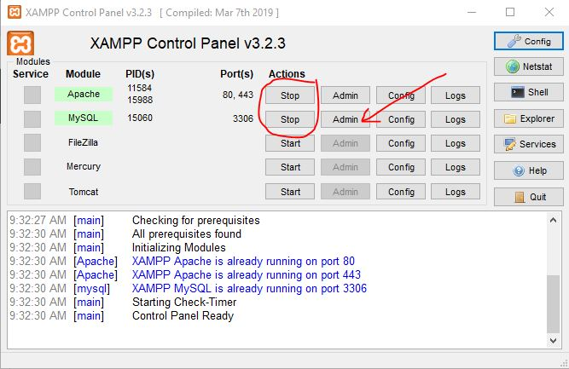

4] Using the left hand menu, create a new database and name it ris.

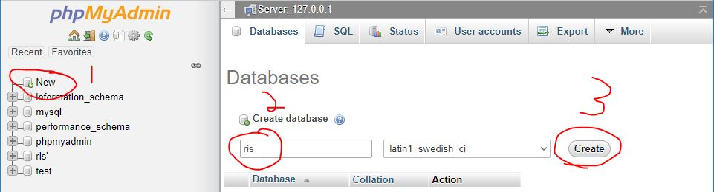

5] Select the database ris in the left hand menu, select the SQL tab, paste the statements copied from ris.sql, and submit. This will create the database with all current data.

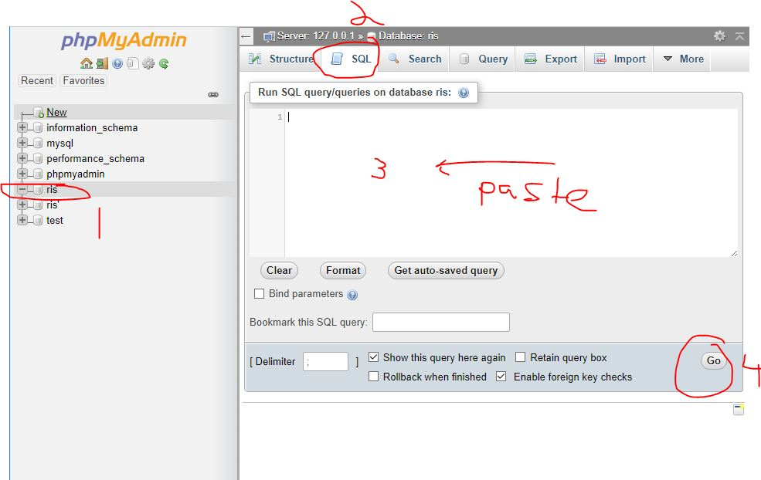

**Installation: Java Client**

1] Download IntelliJ Community Edition, or IntelliJ Ultimate Edition if access is granted through the UNG software portal.

<https://www.jetbrains.com/idea/download/#section=windows>

2] Find the RISFx folder in the source code folder. This will be the project we open. Open the project in IntelliJ.

3] Depending on what software you already have, you may be required to install Java JDK and attach it to the project. Download Java SDK 11.0.2.

4] Find and click the project structure button top right.

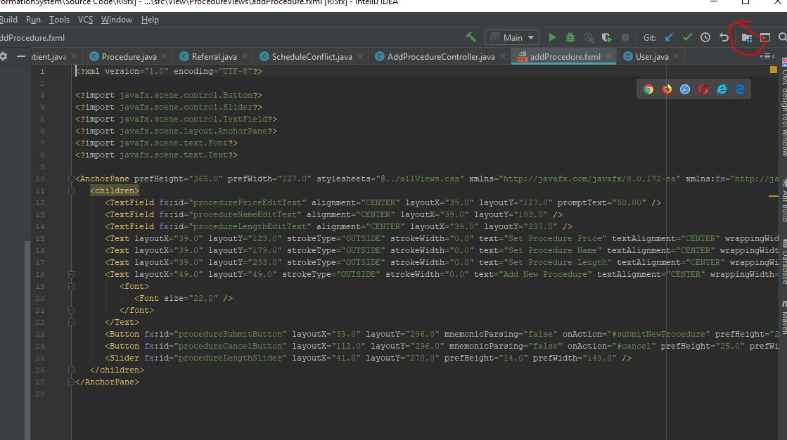

5] Select the filepath of the SDK so the IDE knows where it is.

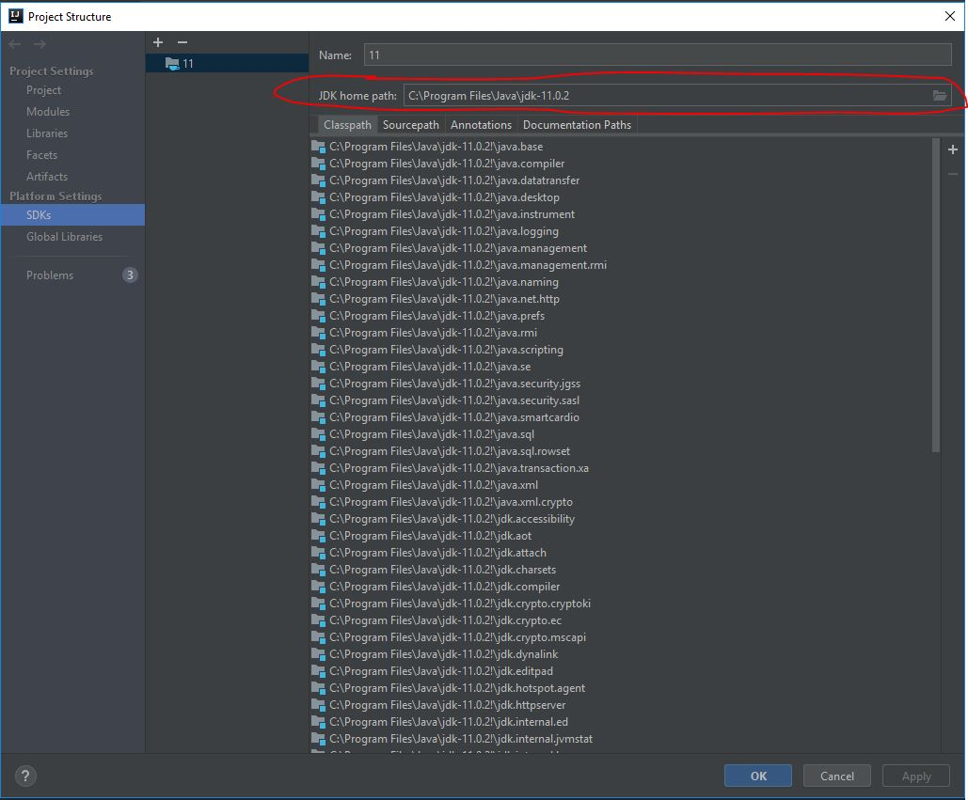

6] Make sure project SDK is selected.

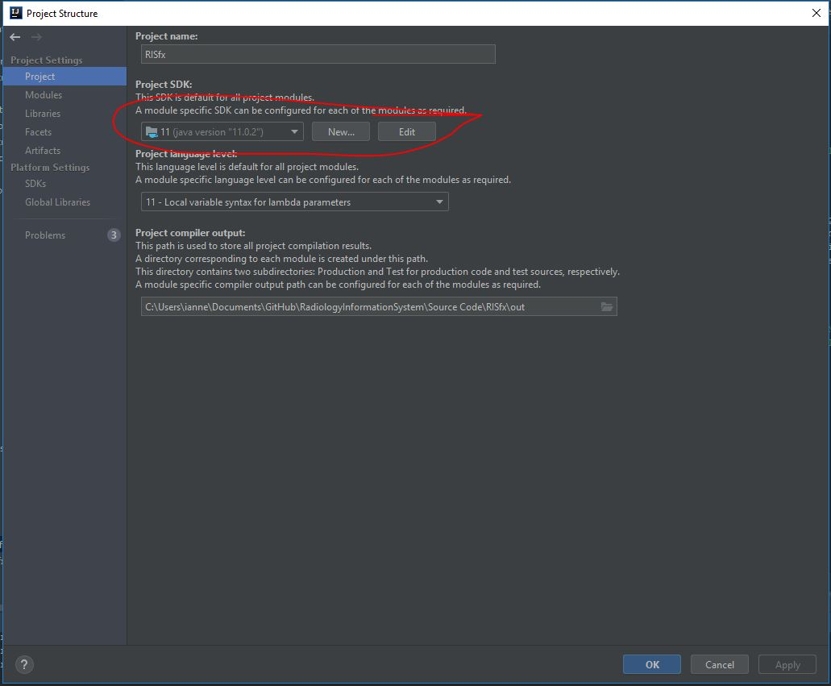

7] In some cases, we have found a bug where VM options aren’t set correctly. In the IDE, Open “Run”>”Edit Configurations” to open the following popup, and make sure the settings are correct.

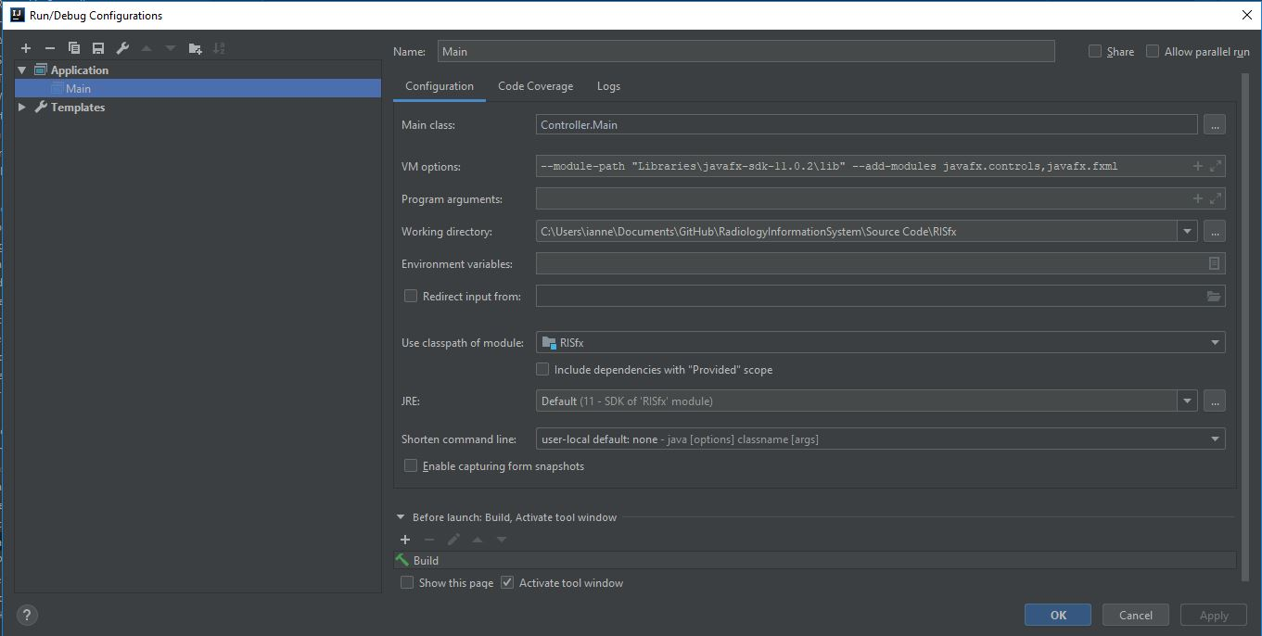

8] You’re now ready to run. Select the java file Main in the controllers folder and run.

9] The login info is stored in the ris.sql text (try ctrl+F for chrispratt). Assuming this document is not out of date, the following login names should work the with password 1234.

